1. Create one VPC, with 1 public subnet and 1 private subnet.
Created one VPC:
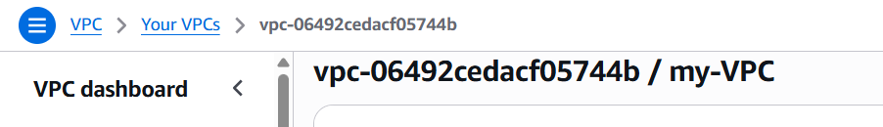
created one public subnet:
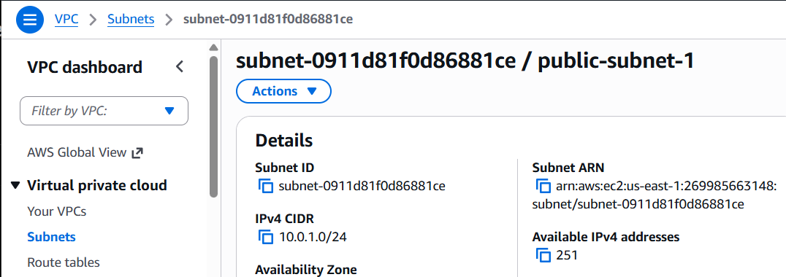
Created one private subnet:
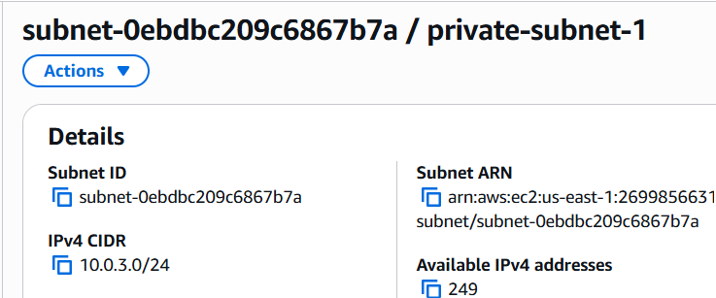

2) Enable VPC peering for cross-region.
Example
- Region 1: us-east-1
- Region 2: us-west-1

Steps
- Create another VPC in us-west-1.
  - CIDR: 192.168.0.0/16
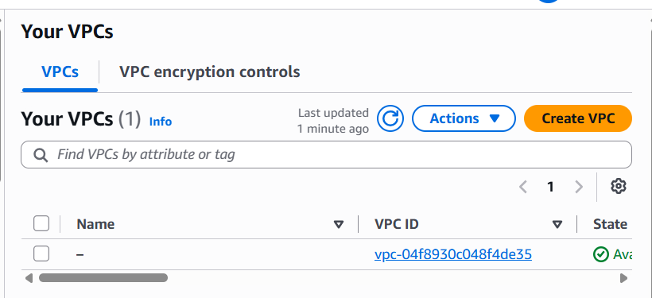
  - 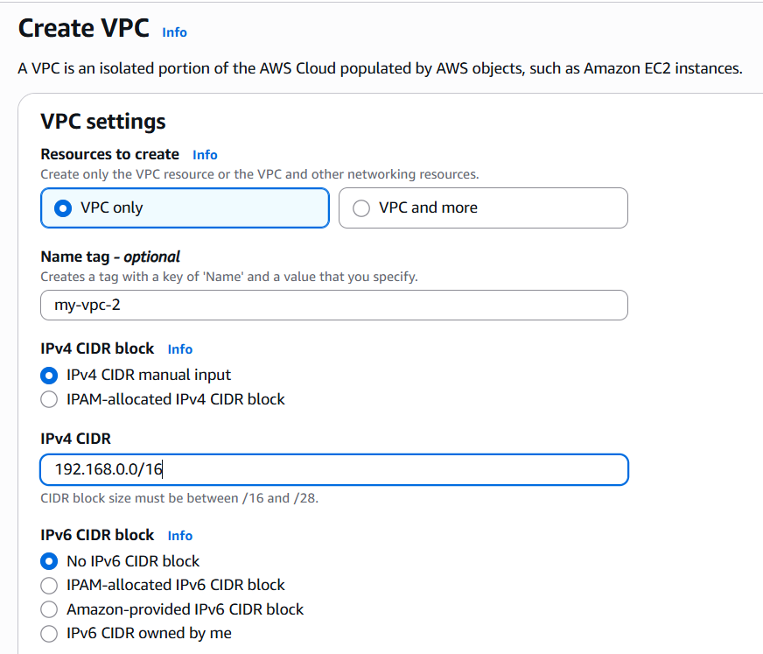
After creating:
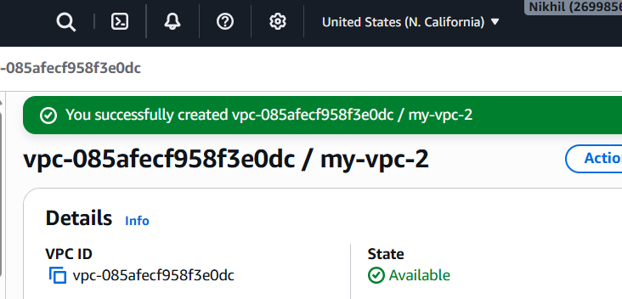
- Go to VPC → Peering Connections.
- Click Create Peering Connection.
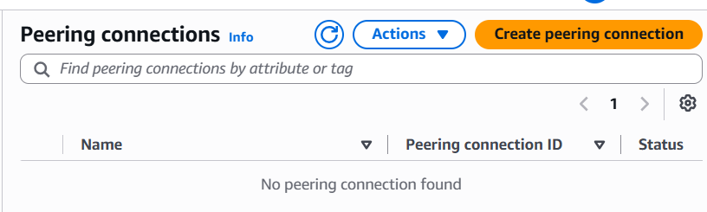
Configure:
- Requester VPC → VPC in us-east-1
- Accepter VPC → VPC in us-west-1
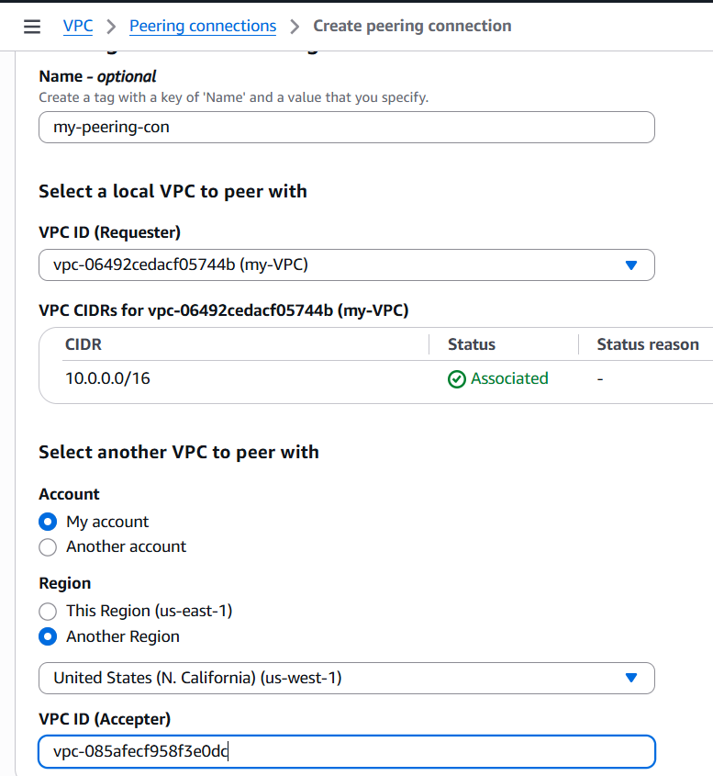
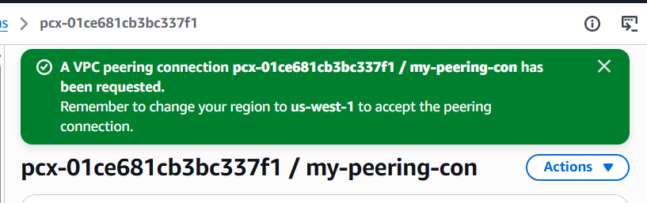
- Switch to us-west-2.
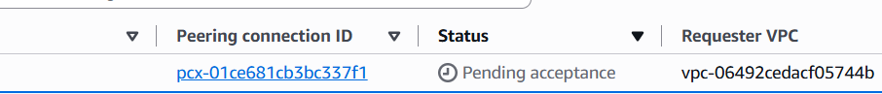
- Accept the peering request.
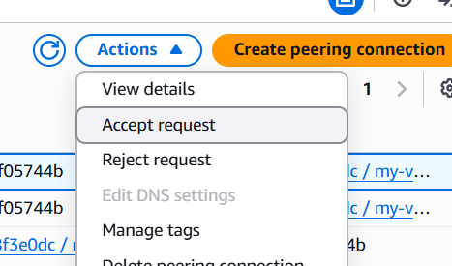
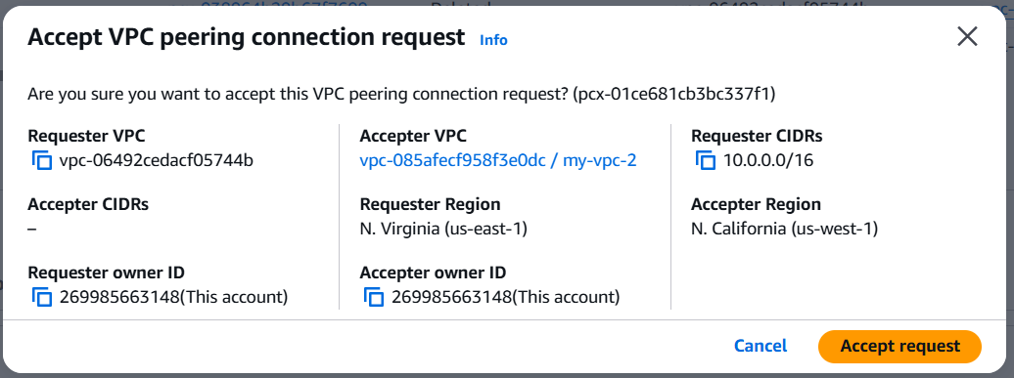
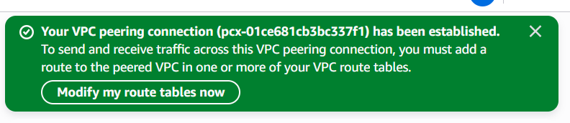
Status should be active
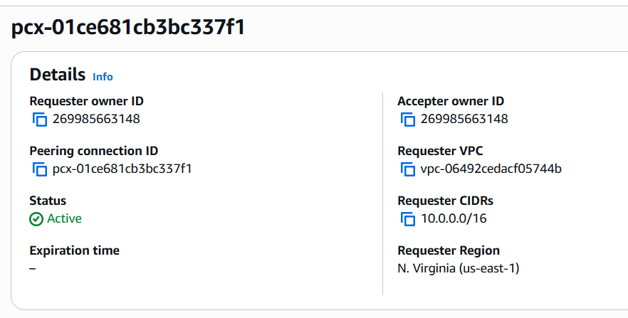
- Update both VPCs' route tables.
Example:
VPC 1 Route Table
Destination | Target
192.168.0.0/16 | Peering Connection
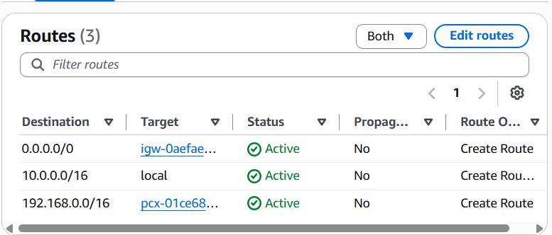
VPC 2 Route Table
Destination | Target
10.0.0.0/16 | Peering Connection

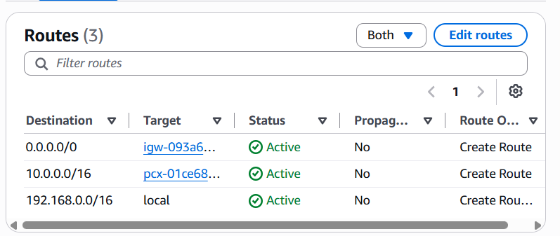
7. Check the status of peering connection in both regions
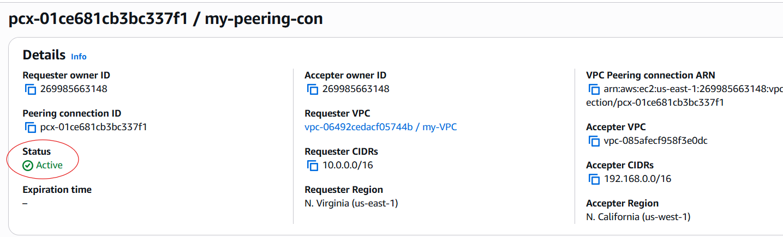
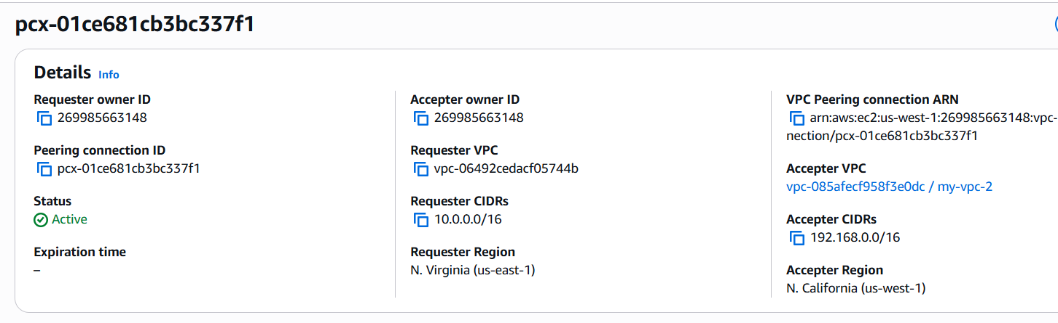

3) Enable VPC peering for cross-account (you can collaborate with your friend to do this task).
Account A
Create:
- VPC: 10.0.0.0/16
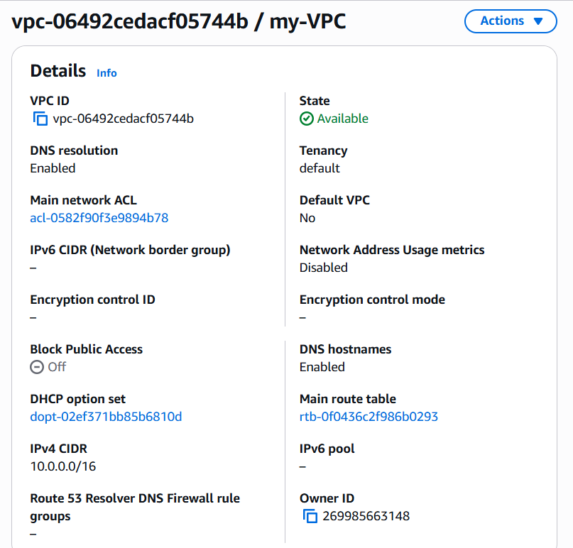

Account B
Create:
- VPC: 172.168.0.0/24

Steps
- Account A creates a peering request.
- Enter:
  - Friend's AWS Account ID
  - Friend's VPC ID
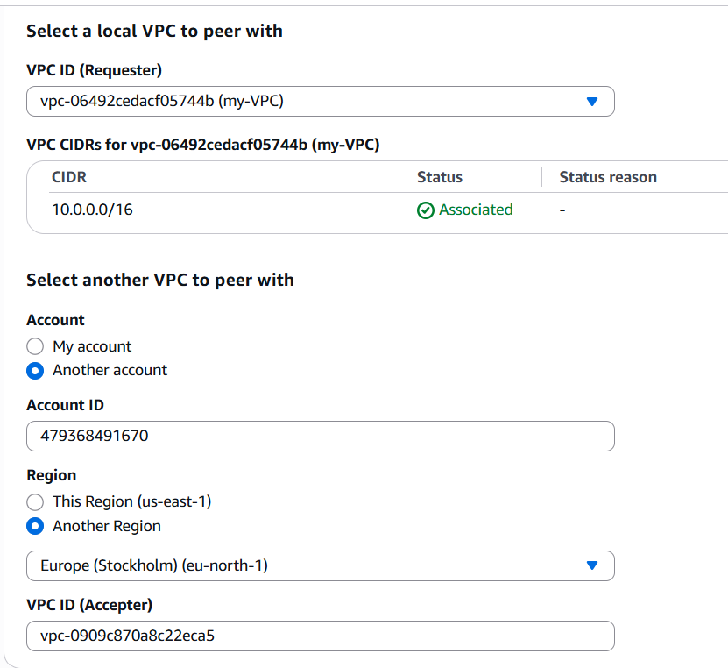
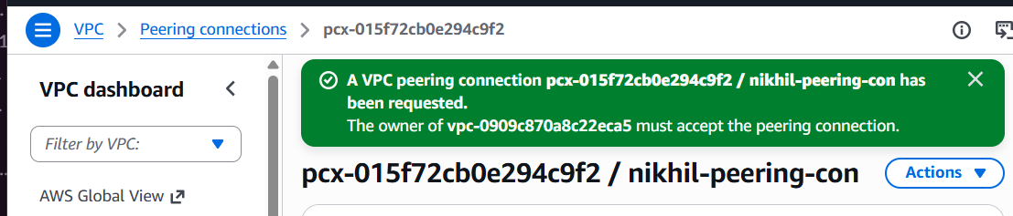
- Friend logs in.
- Accepts the peering request.
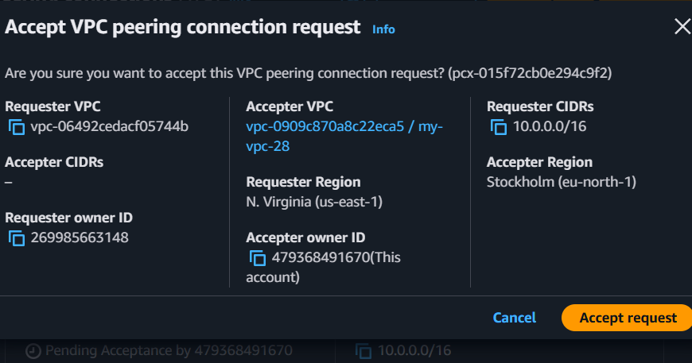
- Both accounts update their route tables.
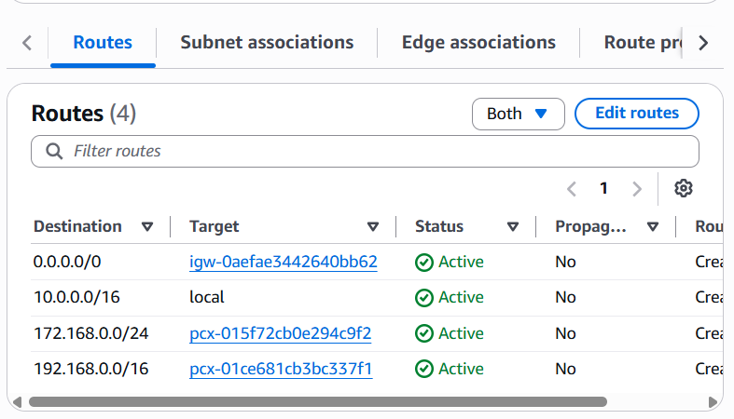
Example:
Account A
Destination | Target
172.168.0.0/24 | Peering
Account B
Destination | Target
10.0.0.0/16 | Peering
4) Set up a VPC Transit Gateway.
You need 2 VPCs in the same AWS Region.
For example:
VPC | Region | CIDR
VPC-1 | us-east-1 | 10.0.0.0/16
VPC-2 | us-east-1 | 172.16.0.0/16
Then:
Transit Gateway
/ \
/ \
VPC-1 (10.0.0.0/16) VPC-2 (172.16.0.0/16)
step 1: create the VPC
After creating the new VPC, configure it by assigning the following
- Internet Gateway
- Public and private subnets
- Public and private route tables
- Subnet associations
Already created one vpc: 
created one public subnet:

Created one private subnet:

step 2: create another new VPC
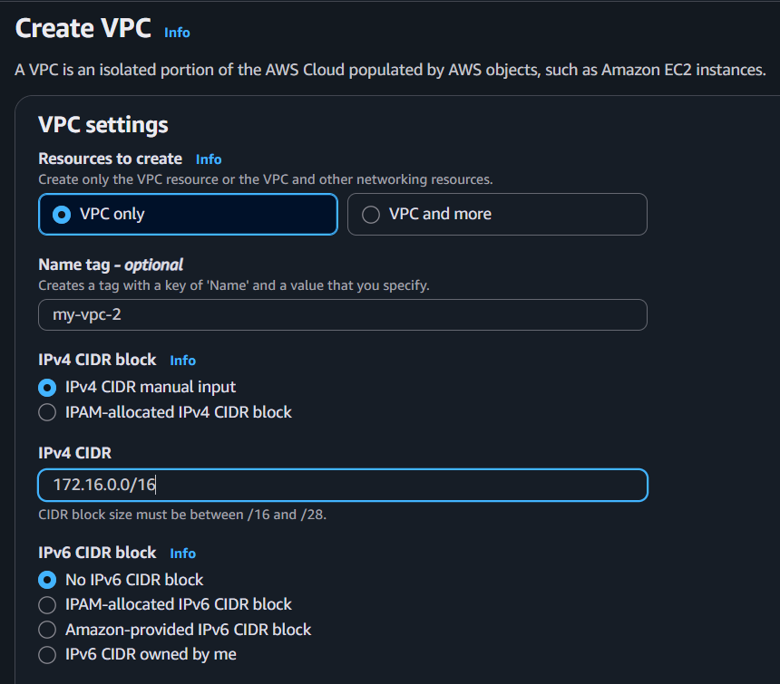
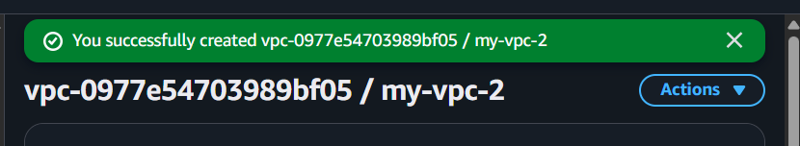
configure the created VPC by assigning the following
- Internet Gateway
- Public and private subnets
- Public and private route tables
- Subnet associations
Step 3: Creating Transit Gateway
- Go to VPC → Transit Gateways.
- Click Create Transit Gateway.
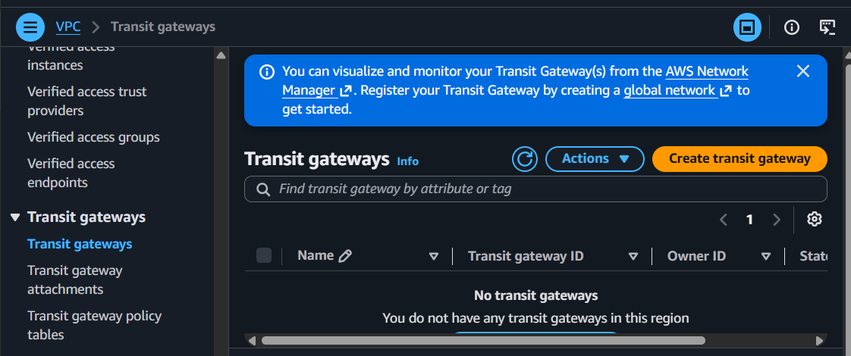
- Give it a name:
  - My-TGW
- Leave defaults.
- Create it.
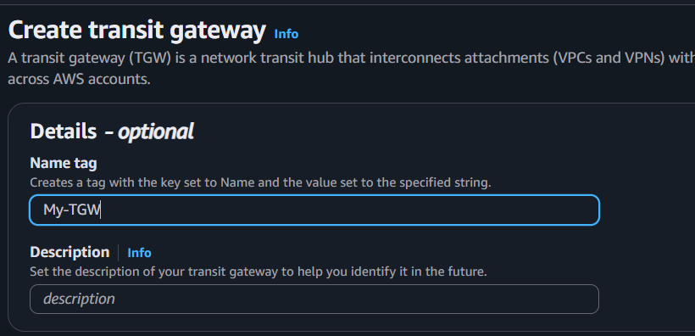

Attach VPCs
- Go to Transit Gateway Attachments.
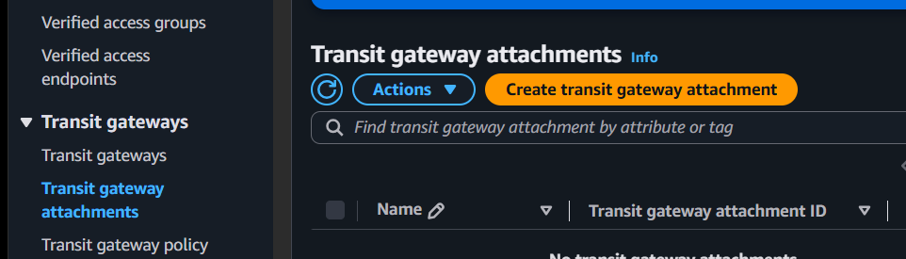
- Click Create Attachment.
- Select:
  - Transit Gateway
  - VPC
  - One subnet from each Availability Zone you want to use
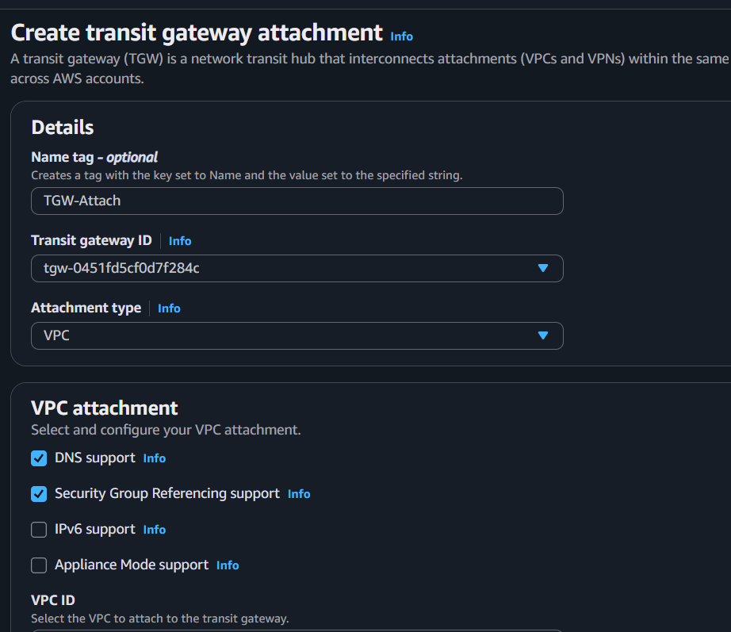
  - 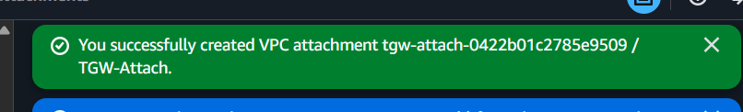
- Repeat for first VPC also
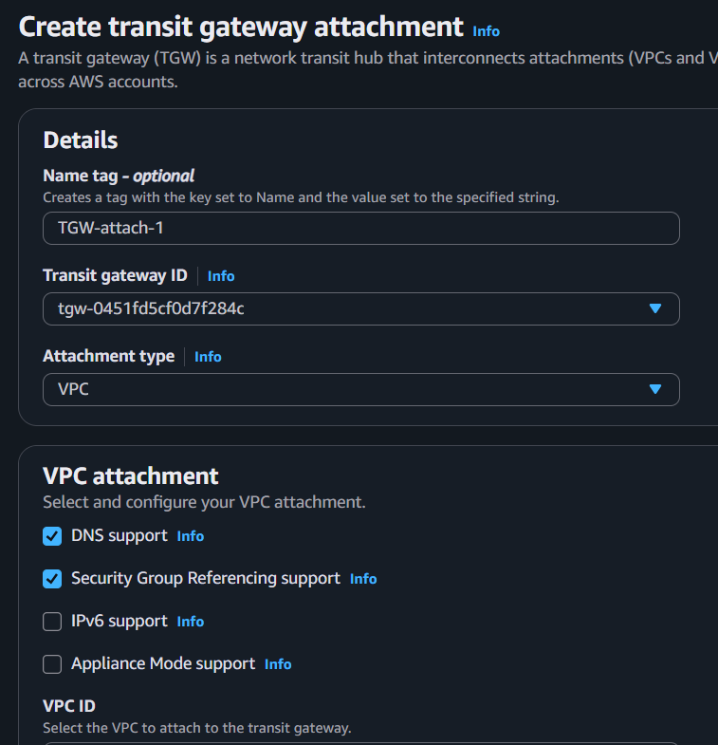
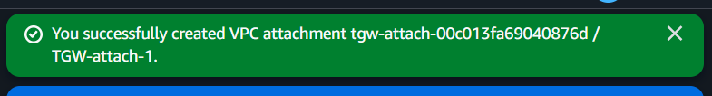

Step 4: After both attachments become Available
We'll update the route tables.

In VPC-1 Route Table
Add:
Destination | Target
172.16.0.0/16 | Transit Gateway

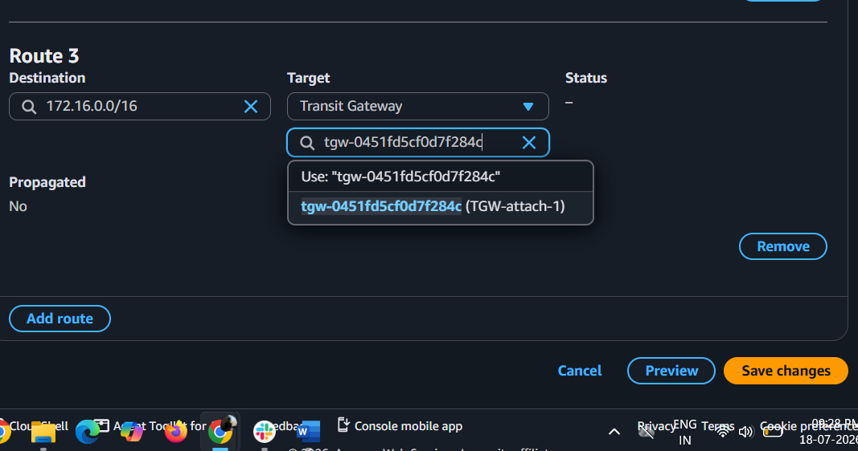
In VPC-2 Route Table
Add:
Destination | Target
10.0.0.0/16 | Transit Gateway

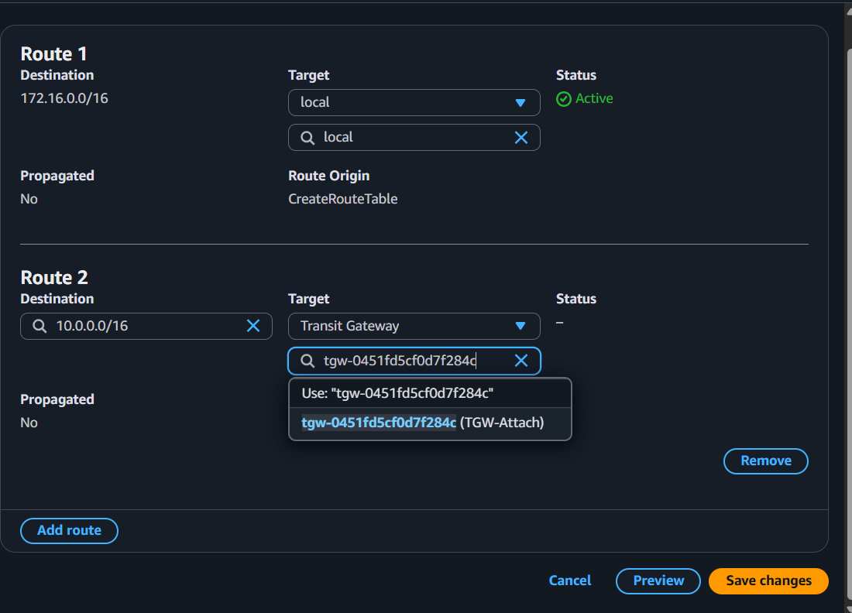
Verify the setup

1. Check Transit Gateway Attachments
Go to:
VPC → Transit Gateway Attachments
Both attachments should have the status:
Available
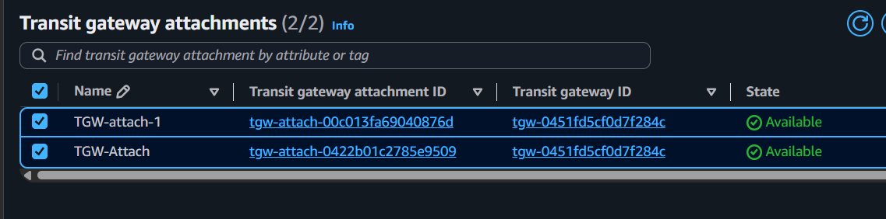

2. Check Route Tables and Verify:
VPC-1
10.0.0.0/16 → Local
172.16.0.0/16 → Transit Gateway
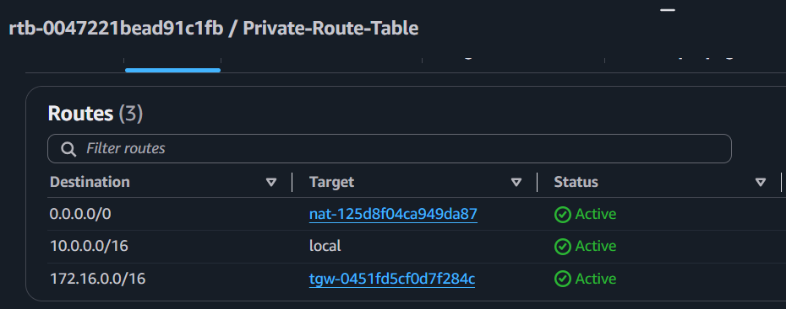
VPC-2
172.16.0.0/16 → Local
10.0.0.0/16 → Transit Gateway
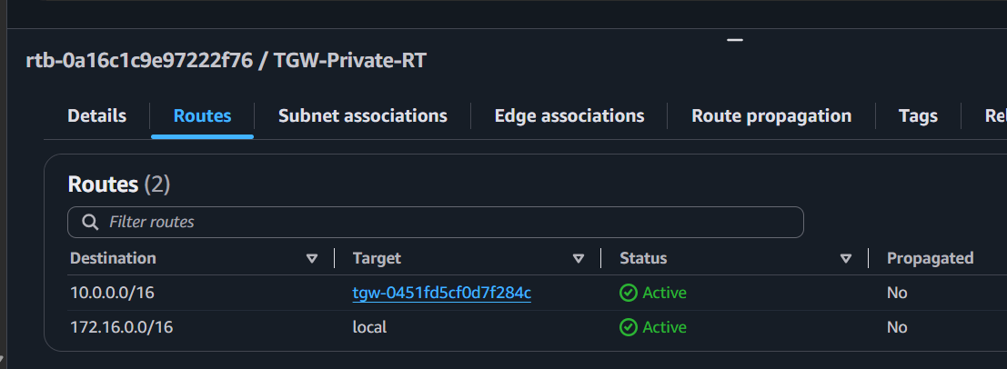

5) Set up a VPC Endpoint.
Architecture
EC2 (Private Subnet)
│
│
VPC Endpoint (Gateway)
│
│
Amazon S3
The benefit is that instances in VPC can access Amazon S3 without using the Internet Gateway or NAT Gateway.

Step 1: Open Endpoints
Go to:
VPC → Endpoints
Click Create endpoint.
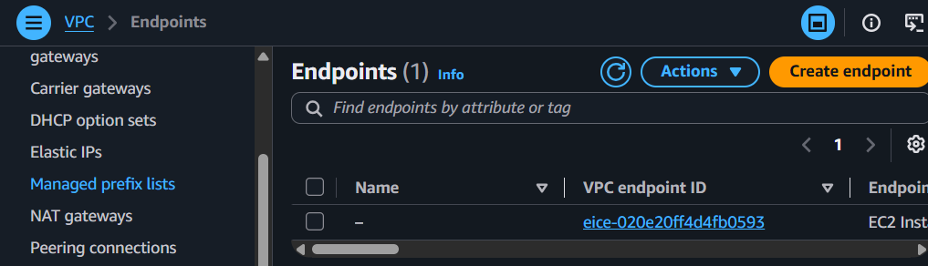

Step 2: Configure the Endpoint

Name
S3-myvpc-Endpoint

Service Category
Select:
AWS services

Service
Search for:
S3
Select the service that looks like:
com.amazonaws.us-east-1.s3
Type should be:
Gateway
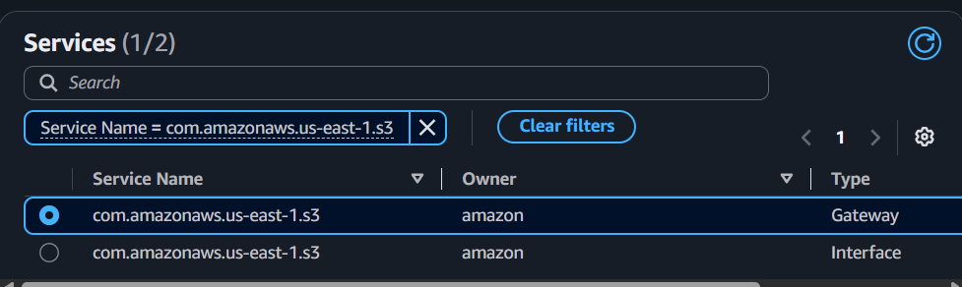

Step 3: Select the VPC
Choose your VPC.
Example:
VPC-1
(You can also choose the second VPC if that's the one you want to use.)

Step 4: Route Tables
This is the most important step.
AWS asks you to select Route Tables.
Select the route table associated with the subnet(s) that should access S3.
Usually select:
- ✅ Private Route Table
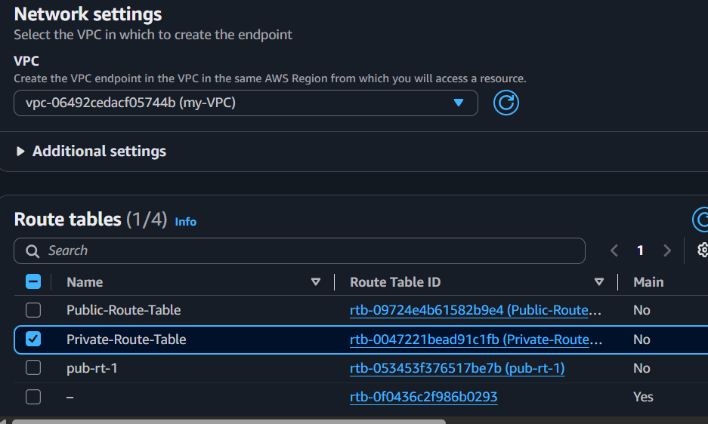

Step 5: Endpoint Policy
Choose:
Full Access
(Keep the default policy.)

Step 6: Create Endpoint
Click Create Endpoint
After creating it shows successfully created VPC endpoint.
Wait about one minute.
The endpoint status should become:
Available
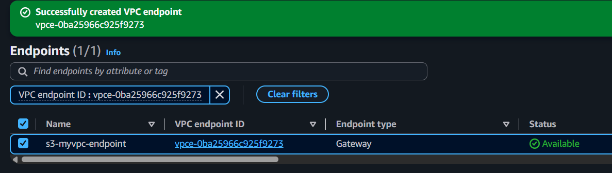

Step 7: Verify
Go to:
VPC → Endpoints
You should see something like:
Name | Type | State
S3-VPC-Endpoint | Gateway | Available

Step 8: Check the Route Table
Open the route table you selected.
You'll notice AWS automatically added a route similar to:
Destination | Target
S3 Prefix List (pl-xxxxxxxx) | VPC Endpoint (vpce-xxxxxxxx)
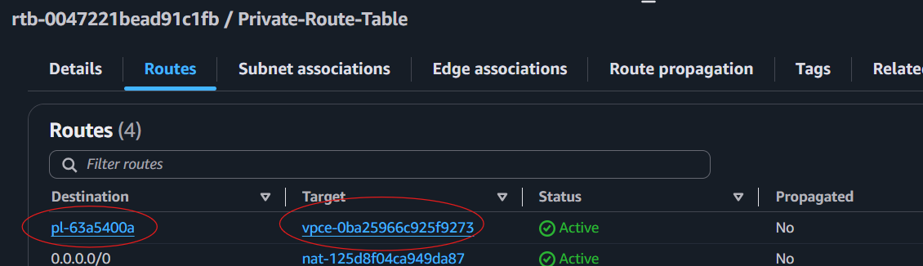
This confirms the Gateway Endpoint is active.
Now, instances in the associated private subnet can access S3 through the endpoint instead of going through the internet.

